**Intelligent Customer Retention using machine learning for enhanced prediction of telecom customer churn**

INTRODUCTION:

Churn prediction is predicting which customers are at high risk of leaving your company or canceling a subscription to a service, based on their behavior with your product.

1.1 OVERVIEW

**Project Description:**

The "Intelligent customer retention using machine learning for enhanced prediction of telecom customer churn" project aims to use machine learning algorithms to predict which telecom customers are at risk of churning. The project will focus on analyzing customer data such as usage patterns, call duration, and complaint history to identify the key indicators of churn.

The main objectives of this project are as follows:

1. Data collection and cleaning: The first step will be to gather data from various sources such as call logs, usage patterns, billing data, and customer complaints. The data will be cleaned and prepared for analysis.

2. Feature engineering: In this step, relevant features will be extracted from the data and engineered to improve the accuracy of the machine learning models.

3. Model selection and training: The project will involve training and testing various machine learning models such as logistic regression, decision trees, and random forests to identify the best-performing model for predicting customer churn.

4. Model evaluation and tuning: Once the best-performing model has been identified, it will be fine-tuned and evaluated on a test dataset to ensure that it is robust and accurate.

5. Deployment: The final step will be to deploy the model in a production environment where it can be used to predict customer churn and take proactive measures to retain at-risk customers.

The outcome of this project will be an intelligent customer retention system that can help telecom companies reduce churn and increase customer loyalty. The system will be able to identify which customers are most likely to churn and take proactive measures to retain them, such as offering personalized incentives, improving the customer experience, or addressing customer complaints before they escalate. Overall, the project will help telecom companies improve customer satisfaction, reduce churn, and increase revenue over the long term

**1.2 The use of this project. What can be achieved using this.**

Predicting customer churn: By analyzing customer data such as usage patterns, call duration, and complaint history, the machine learning model developed in this project can predict which customers are at risk of churning. This can help telecom companies take proactive measures to retain those customers.

Improving customer experience: The model can help telecom companies identify areas where they can improve the customer experience, such as addressing customer complaints before they escalate or offering personalized incentives to retain at-risk customers.

Reducing churn: By identifying and retaining high-value customers, telecom companies can reduce churn and increase customer loyalty. This can lead to higher revenue over the long term, as loyal customers are more likely to make repeat purchases and recommend products or services to others.

Saving costs: Acquiring new customers is much more expensive than retaining existing ones. By reducing churn, telecom companies can save on customer acquisition costs and increase profitability.

Overall, the "Intelligent customer retention using machine learning for enhanced prediction of telecom customer churn" project can help telecom companies improve customer satisfaction, reduce churn, increase revenue, and save costs.

**Problem Definition & Design Thinking**

**2.1 Empathy Map**

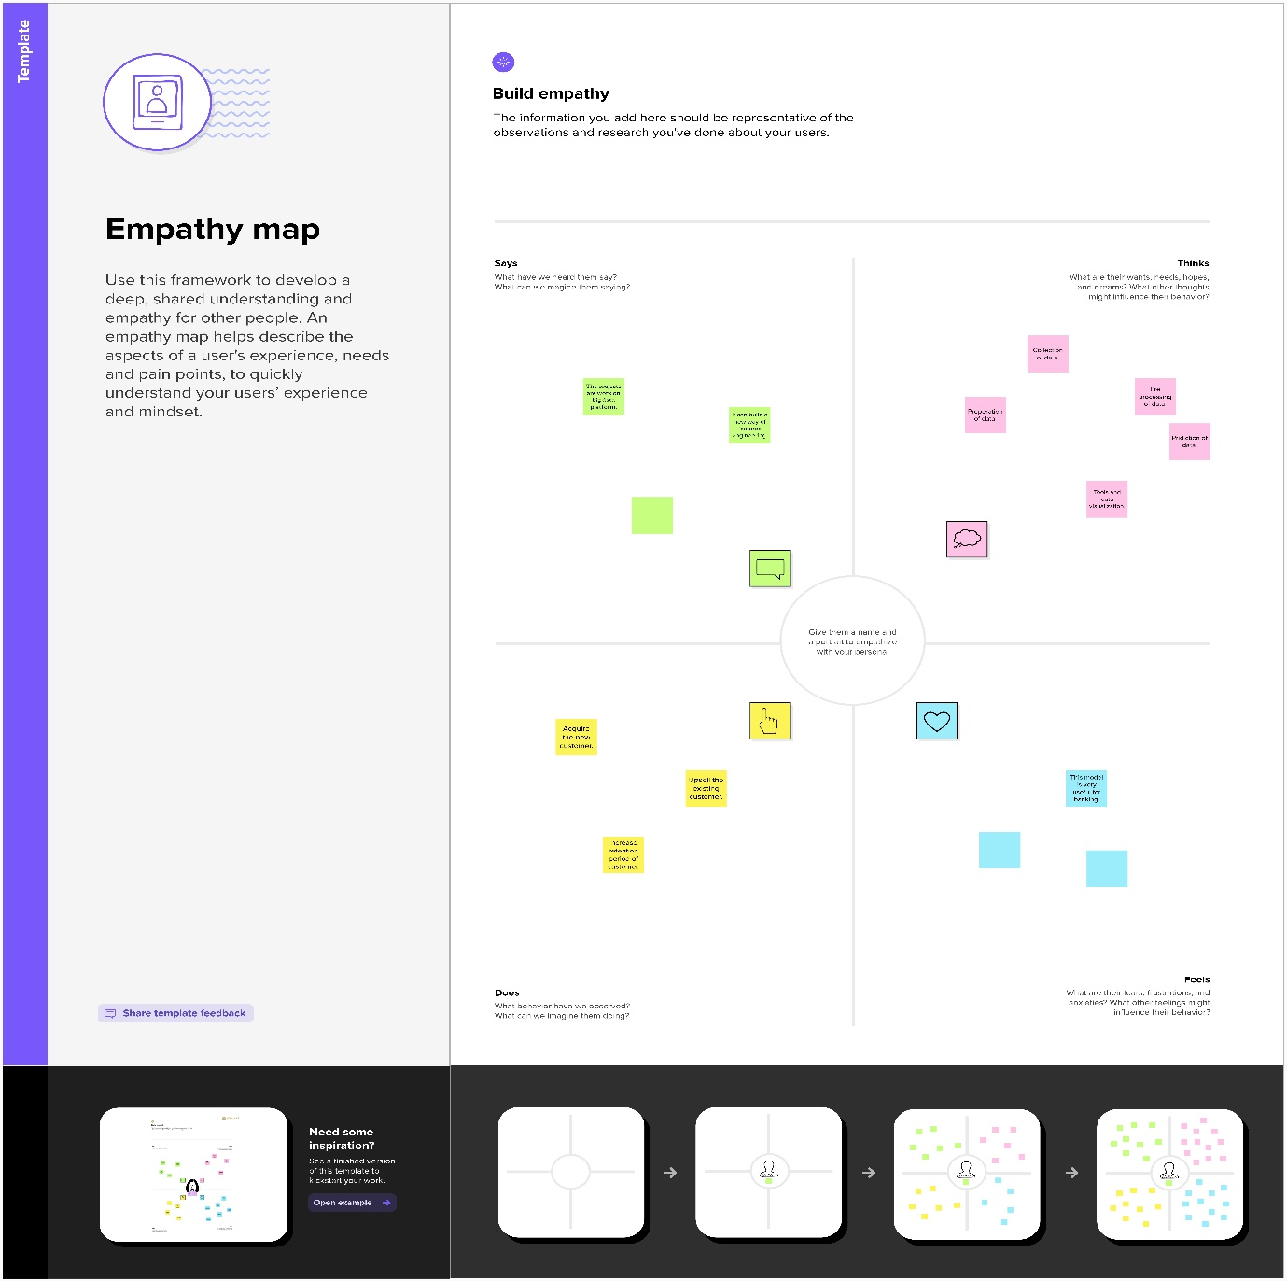

**2.2 Ideation & Brainstorming Map**

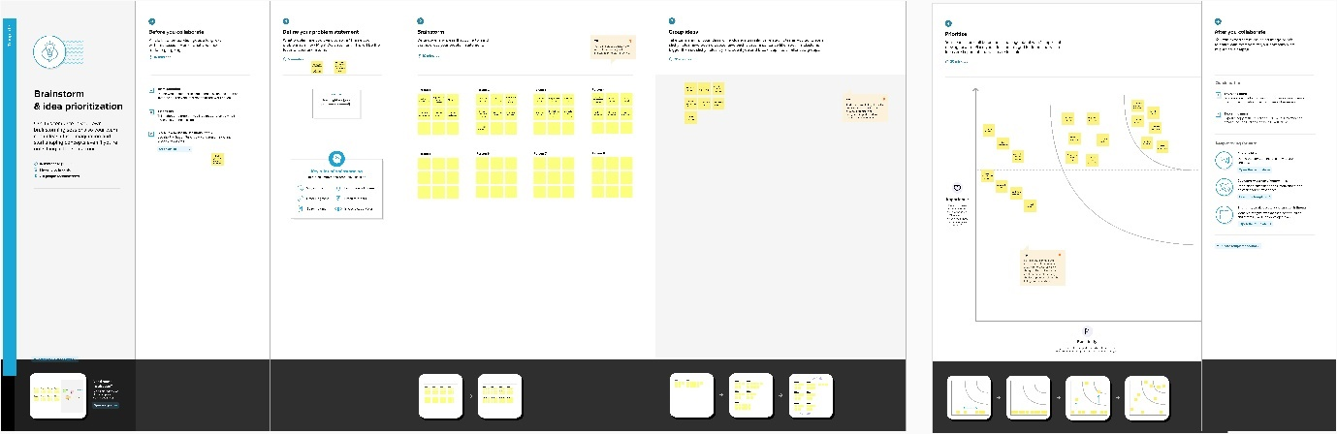

**RESULT**

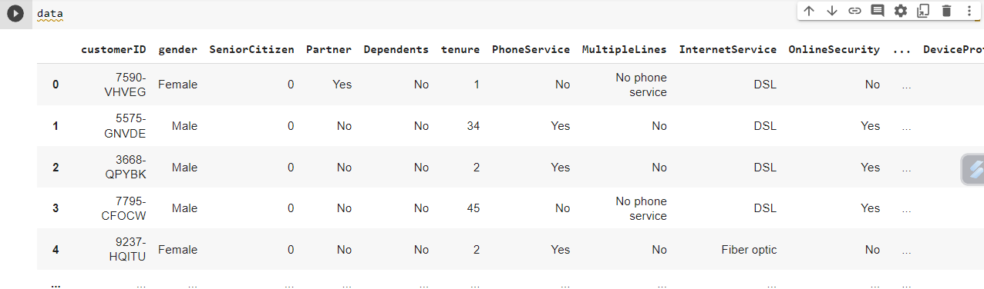

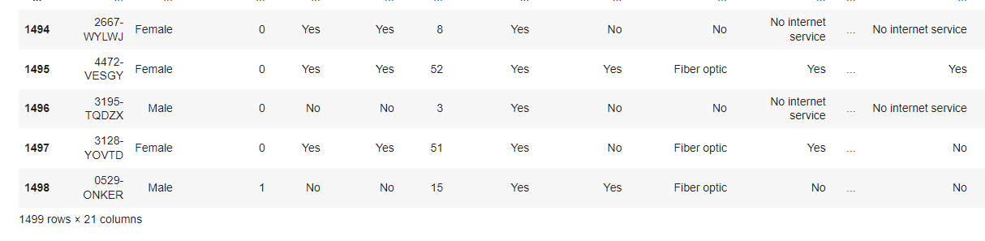

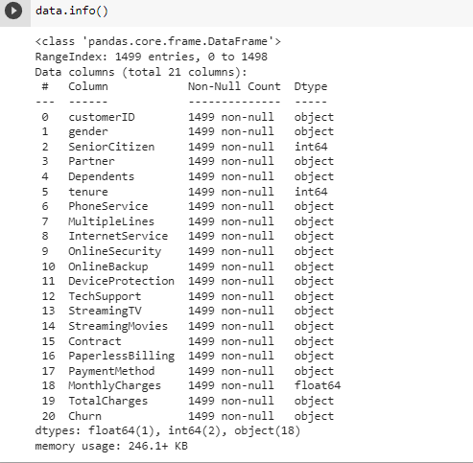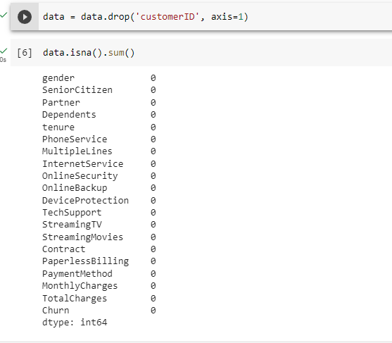

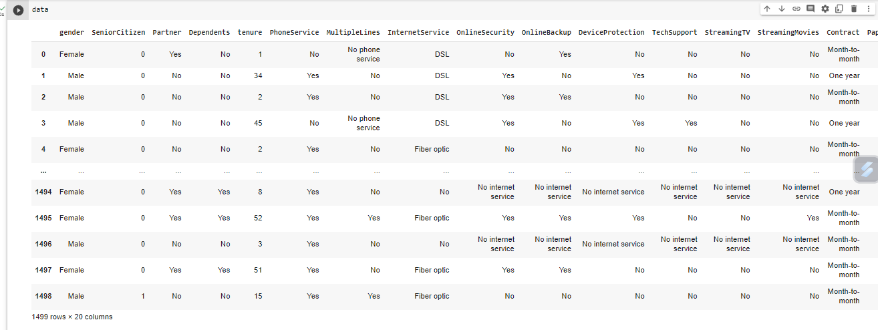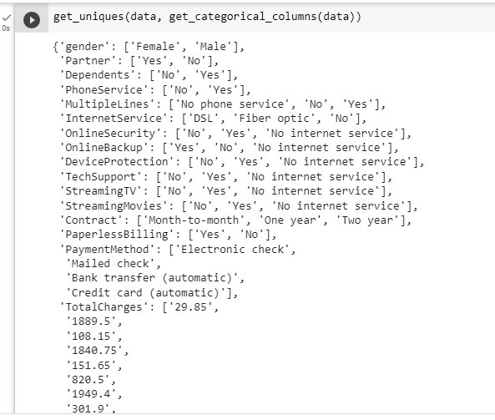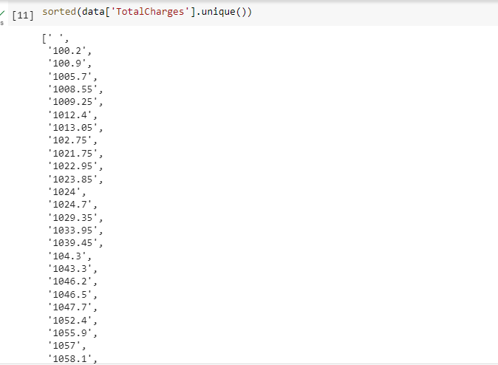

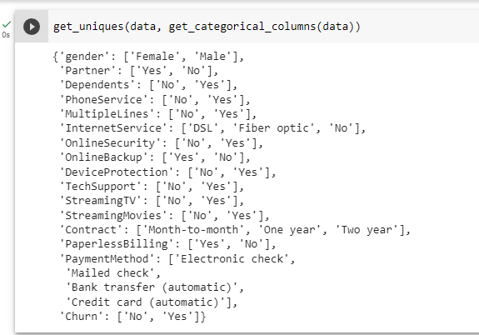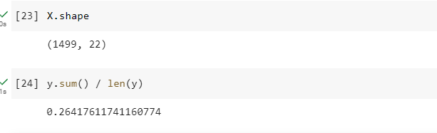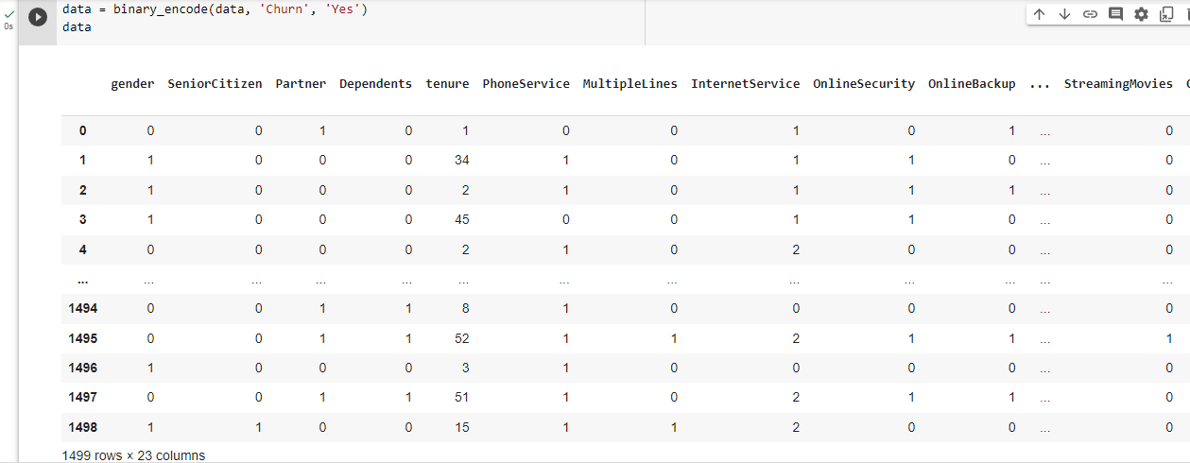

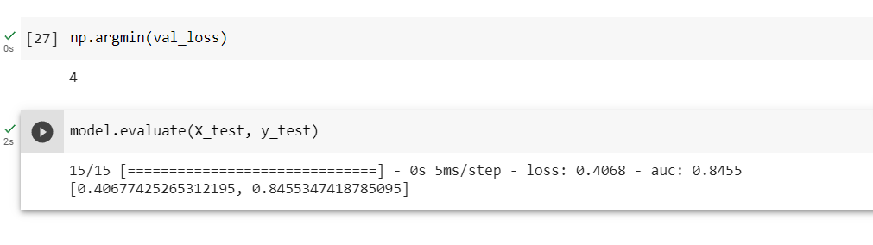

**ADVANTAGES & DISADVANTAGES**

Advantages of "Intelligent customer retention using machine learning for enhanced prediction of telecom customer churn":

Better customer retention: The use of machine learning algorithms can help telecom companies to identify and retain customers who are at risk of churning. This can lead to better customer retention rates and increased revenue over the long term.

Cost-effective: Customer retention is much more cost-effective than acquiring new customers. By retaining high-value customers, telecom companies can save on customer acquisition costs and increase profitability.

Improved customer experience: The use of machine learning algorithms can help telecom companies to identify areas where they can improve the customer experience, such as addressing customer complaints before they escalate or offering personalized incentives to retain at-risk customers.

Accurate predictions: The use of machine learning algorithms can lead to more accurate predictions of customer churn than traditional methods. This can help telecom companies to take proactive measures to retain at-risk customers.

Disadvantages of "Intelligent customer retention using machine learning for enhanced prediction of telecom customer churn":

Data quality: The accuracy of machine learning models is heavily dependent on the quality of the data used to train them. If the data is incomplete or inaccurate, the predictions generated by the model may also be inaccurate.

Lack of interpretability: Machine learning algorithms can be difficult to interpret, making it challenging to understand how they arrive at their predictions. This can be a disadvantage if telecom companies are looking for insights into why customers are churning.

High cost: Implementing machine learning algorithms can be expensive, both in terms of the cost of acquiring the necessary technology and the cost of hiring skilled data scientists to develop and deploy the models.

Limited application: Machine learning algorithms may not be applicable to all telecom companies or situations. For example, smaller telecom companies may not have enough data to train accurate models, or the data may be too complex to analyze using machine learning algorithms.

**APPLICATIONS**

The "Intelligent customer retention using machine learning for enhanced prediction of telecom customer churn" project has several potential applications in the telecom industry. Here are a few examples:

Predicting customer churn: The primary application of this project is to predict which customers are at risk of churning. This can help telecom companies take proactive measures to retain those customers, such as offering personalized incentives or improving the customer experience.

Customer segmentation: Machine learning algorithms can be used to segment customers based on their usage patterns, demographics, and other factors. This can help telecom companies tailor their marketing and retention strategies to different customer segments.

Product development: By analyzing customer data, telecom companies can gain insights into what products and services are most in demand. This can help them develop new products or improve existing ones to better meet customer needs.

Fraud detection: Machine learning algorithms can be used to detect fraudulent activity, such as stolen or cloned SIM cards. This can help telecom companies reduce losses due to fraud and protect their customers' data and privacy.

Network optimization: By analyzing network usage patterns, machine learning algorithms can help telecom companies optimize their networks for better performance and efficiency. This can lead to a better customer experience and lower costs for the telecom company.

Overall, the "Intelligent customer retention using machine learning for enhanced prediction of telecom customer churn" project has many potential applications in the telecom industry. By analyzing customer data using machine learning algorithms, telecom companies can gain valuable insights into customer behavior and preferences, which can help them improve customer satisfaction, reduce churn, increase revenue, and save costs.

**CONCLUSION**

In conclusion, the "Intelligent customer retention using machine learning for enhanced prediction of telecom customer churn" project has the potential to be a game-changer for the telecom industry. By leveraging the power of machine learning algorithms, telecom companies can gain valuable insights into customer behavior and preferences, which can help them improve customer satisfaction, reduce churn, increase revenue, and save costs.

The primary goal of this project is to predict which customers are at risk of churning, allowing telecom companies to take proactive measures to retain those customers. However, the potential applications of this project go far beyond churn prediction. Telecom companies can use machine learning algorithms to segment customers, develop new products, detect fraud, and optimize their networks for better performance and efficiency.

While there are some potential drawbacks to implementing machine learning algorithms in the telecom industry, such as data quality issues and the high cost of implementation, the potential benefits far outweigh the risks. By investing in this technology, telecom companies can improve their bottom line, retain high-value customers, and deliver a better customer experience.

Overall, the "Intelligent customer retention using machine learning for enhanced prediction of telecom customer churn" project is an exciting opportunity for telecom companies to leverage the power of machine learning algorithms to gain a competitive advantage in the marketplace.

**FUTURE SCOPE**

Multi-dimensional analysis: Future iterations of this project can incorporate more dimensions of analysis, such as customer sentiment analysis, social media monitoring, and data from other sources. This can help telecom companies gain more comprehensive insights into customer behavior and preferences.

Real-time analysis: Real-time analysis of customer data can help telecom companies take proactive measures to retain at-risk customers. Future developments in machine learning technology can enable faster and more accurate predictions, allowing telecom companies to intervene before customers churn.

Personalization: Personalized retention strategies can be developed by analyzing customer data on an individual level. Future research can focus on developing machine learning algorithms that can provide personalized recommendations for retaining at-risk customers.

Integration with other systems: Machine learning algorithms can be integrated with other telecom systems, such as billing and customer service, to provide a seamless and comprehensive customer experience. Future research can explore the potential benefits of integrating machine learning algorithms with other systems.

Generalization: The predictive models developed through this project can be generalized to other industries beyond telecom, such as retail, healthcare, and finance. This can help other industries improve their customer retention strategies and provide better customer experiences.

Overall, the "Intelligent customer retention using machine learning for enhanced prediction of telecom customer churn" project has a bright future with many potential directions for further research and development. By continuing to improve and refine machine learning algorithms for customer retention, telecom companies can stay ahead of the competition and deliver better customer experiences.

**APPENDIX**

import numpy as np

import pandas as pd

import matplotlib.pyplot as plt

from sklearn.preprocessing import StandardScaler

from sklearn.model_selection import train_test_split

import tensorflow as tf

In [2]:

data = pd.read_csv('../input/telco-customer-churn/WA_Fn-UseC_-Telco-Customer-Churn.csv')

In [3]:

linkcode

data

data.info()

data = data.drop('customerID', axis=1)

In [6]:

data.isna().sum()

def get_uniques(df, columns):

return {column: list(df[column].unique()) for column **in** columns}

In [9]:

def get_categorical_columns(df):

return [column for column **in** df.columns if df.dtypes[column] == 'object']

In [10]:

get_uniques(data, get_categorical_columns(data))

sorted(data['TotalCharges'].unique())

data['TotalCharges'] = data['TotalCharges'].replace(' ', np.NaN)

data['TotalCharges'] = data['TotalCharges'].astype(np.float)

data['TotalCharges'] = data['TotalCharges'].fillna(data['TotalCharges'].mean())

In [13]:

data['MultipleLines'] = data['MultipleLines'].replace('No phone service', 'No')

data[['OnlineSecurity', 'OnlineBackup', 'DeviceProtection',

'TechSupport', 'StreamingTV', 'StreamingMovies']] = data[['OnlineSecurity', 'OnlineBackup', 'DeviceProtection',

'TechSupport', 'StreamingTV', 'StreamingMovies']].replace('No internet service', 'No')

In [14]:

linkcode

get_uniques(data, get_categorical_columns(data))

binary_features = ['gender', 'Partner', 'Dependents', 'PhoneService', 'MultipleLines',

'OnlineSecurity', 'OnlineBackup', 'DeviceProtection', 'TechSupport',

'StreamingTV', 'StreamingMovies', 'PaperlessBilling']

ordinal_features = ['InternetService', 'Contract']

nominal_features = ['PaymentMethod']

target_column = 'Churn'

In [16]:

linkcode

internet_ordering = ['No', 'DSL', 'Fiber optic']

contract_ordering = ['Month-to-month', 'One year', 'Two year']

def binary_encode(df, column, positive_value):

df = df.copy()

df[column] = df[column].apply(lambda x: 1 if x == positive_value else 0)

return df

def ordinal_encode(df, column, ordering):

df = df.copy()

df[column] = df[column].apply(lambda x: ordering.index(x))

return df

def onehot_encode(df, column):

df = df.copy()

dummies = pd.get_dummies(df[column])

df = pd.concat([df, dummies], axis=1)

df = df.drop(column, axis=1)

return df

data = binary_encode(data, 'gender', 'Male')

yes_features = ['Partner', 'Dependents', 'PhoneService', 'MultipleLines',

'OnlineSecurity', 'OnlineBackup', 'DeviceProtection', 'TechSupport',

'StreamingTV', 'StreamingMovies', 'PaperlessBilling']

for feature **in** yes_features:

data = binary_encode(data, feature, 'Yes')

data = ordinal_encode(data, 'InternetService', internet_ordering)

data = ordinal_encode(data, 'Contract', contract_ordering)

data = onehot_encode(data, 'PaymentMethod')

data = binary_encode(data, 'Churn', 'Yes')

**TRAINING**

X.shape

Out[24]:

(7043, 22)

In [25]:

y.sum() / len(y)

Out[25]:

0.2653698707936959

TRAININGinputs = tf.keras.Input(shape=(22,))

x = tf.keras.layers.Dense(64, activation='relu')(inputs)

x = tf.keras.layers.Dense(64, activation='relu')(x)

outputs = tf.keras.layers.Dense(1, activation='sigmoid')(x)

model = tf.keras.Model(inputs=inputs, outputs=outputs)

model.compile(

optimizer='adam',

loss='binary_crossentropy',

metrics=[tf.keras.metrics.AUC(name='auc')]

)

batch_size = 64

epochs = 5

history = model.fit(

X_train,

y_train,

validation_split=0.2,

batch_size=batch_size,

epochs=epochs,

verbose=0)

**RESULT**

plt.figure(figsize=(14, 10))

epochs_range = range(1, epochs + 1)

train_loss = history.history['loss']

val_loss = history.history['val_loss']

plt.plot(epochs_range, train_loss, label="Training Loss")

plt.plot(epochs_range, val_loss, label="Validation Loss")

plt.title("Training and Validation Loss")

plt.xlabel("Epoch")

plt.ylabel("Loss")

plt.legend()

plt.show()

HTML CODING:

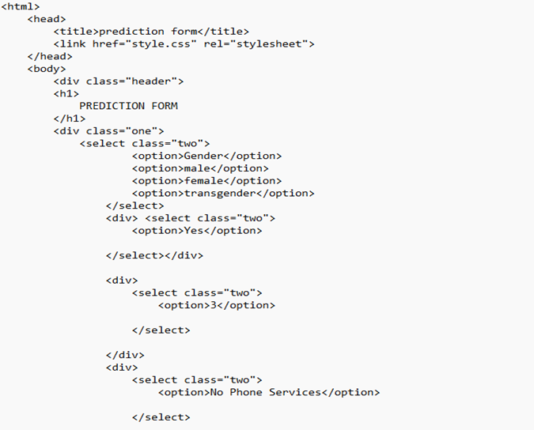

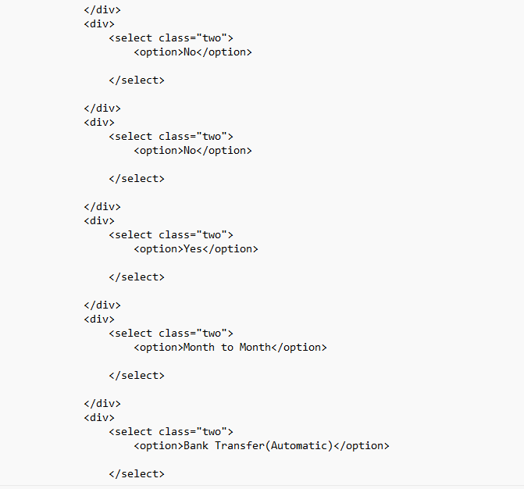

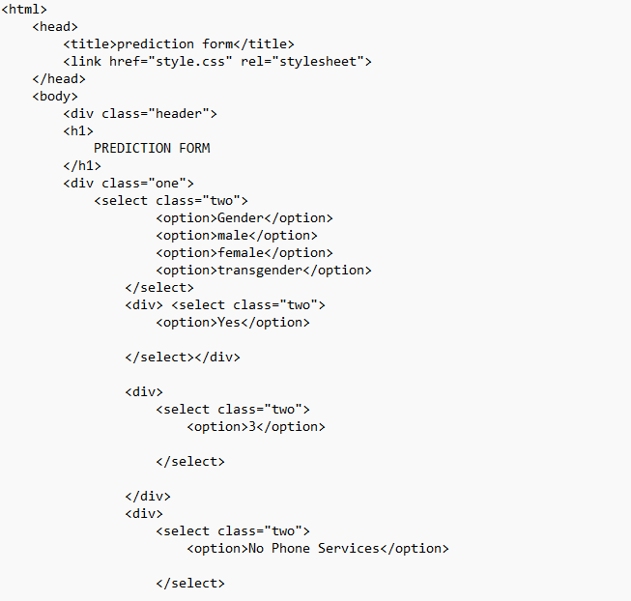

OUTPUT FOR WEB PAGE: